**Operating System**

**(CT-353)**

Lab no 13

**Implement the above code and paste the screen shot of the output.**

**CODE:**

**A) FCFS**

#include <stdio.h>

#include <stdlib.h>

int main() {

int t[20], tohm[20], n, i, tot = 0;

float avhm;

printf("Enter the number of tracks: ");

scanf("%d", &n);

printf("Enter the tracks to be traversed: ");

for (i = 0; i < n; i++) {

scanf("%d", &t[i]);

}

// Calculate the head movements

for (i = 0; i < n - 1; i++) {

tohm[i] = abs(t[i + 1] - t[i]);

tot += tohm[i];

}

avhm = (float)tot / (n - 1);

printf("\nTracks traversed\tDifference between tracks\n");

for (i = 0; i < n - 1; i++) {

printf("%d -> %d\t\t%d\n", t[i], t[i + 1], tohm[i]);

}

printf("\nTotal head movements: %d", tot);

printf("\nAverage head movements: %.2f\n", avhm);

return 0;

}

**OUTPUT:**

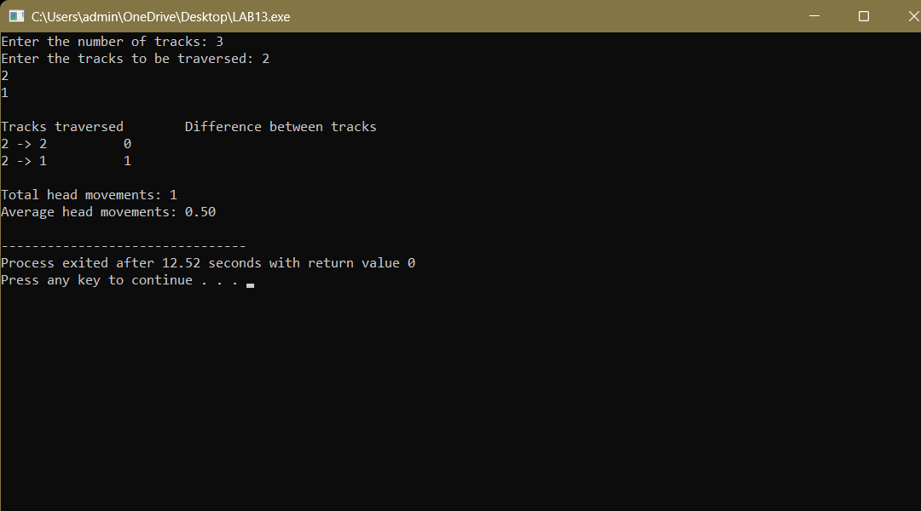

**B) SSTF**

#include <stdio.h>

#include <stdlib.h>

int main() {

int RQ[100], n, initial, TotalHeadMovement = 0, count = 0;

int i, min, d, index, visited[100] = {0};

printf("Enter the number of Requests: ");

scanf("%d", &n);

printf("Enter the Request sequence:\n");

for (i = 0; i < n; i++) {

scanf("%d", &RQ[i]);

}

printf("Enter initial head position: ");

scanf("%d", &initial);

while (count < n) {

min = 100000; // Large value

index = -1;

for (i = 0; i < n; i++) {

if (!visited[i]) {

d = abs(RQ[i] - initial);

if (d < min) {

min = d;

index = i;

}

}

}

visited[index] = 1;

TotalHeadMovement += min;

initial = RQ[index];

count++;

}

printf("Total head movement is: %d\n", TotalHeadMovement);

return 0;

}

**OUTPUT:**

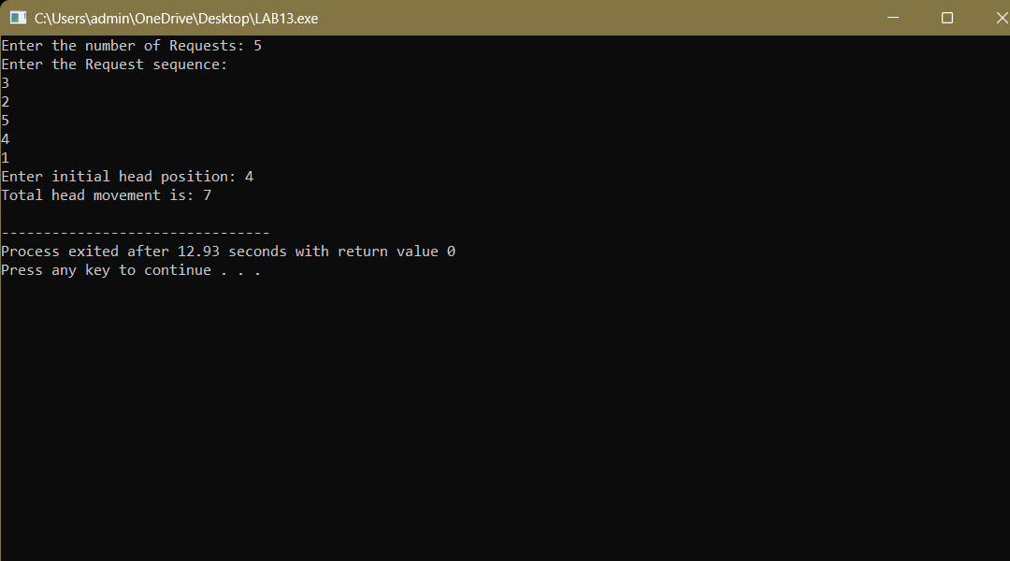

**C) SCAN**

#include <stdio.h>

#include <stdlib.h>

int main() {

int t[100], n, head, i, j, temp;

int totalMovement = 0;

int direction;

printf("Enter the number of tracks to be traversed: ");

scanf("%d", &n);

printf("Enter the position of the head: ");

scanf("%d", &head);

t[0] = head;

printf("Enter the track numbers:\n");

for (i = 1; i <= n; i++) {

scanf("%d", &t[i]);

}

n++; // include the head in the track list

// Sorting the track array

for (i = 0; i < n - 1; i++) {

for (j = 0; j < n - i - 1; j++) {

if (t[j] > t[j + 1]) {

temp = t[j];

t[j] = t[j + 1];

t[j + 1] = temp;

}

}

}

// Ask direction: 0 for left, 1 for right

printf("Enter head movement direction (0 for left, 1 for right): ");

scanf("%d", &direction);

// Find the index of the head

int index;

for (i = 0; i < n; i++) {

if (t[i] == head) {

index = i;

break;

}

}

printf("Order of servicing tracks:\n");

if (direction == 1) {

// Move right

for (i = index; i < n; i++) {

printf("%d ", t[i]);

}

for (i = index - 1; i >= 0; i--) {

printf("%d ", t[i]);

}

} else {

// Move left

for (i = index; i >= 0; i--) {

printf("%d ", t[i]);

}

for (i = index + 1; i < n; i++) {

printf("%d ", t[i]);

}

}

// Calculate total head movement

for (i = 0; i < n - 1; i++) {

totalMovement += abs(t[i + 1] - t[i]);

}

printf("\nTotal head movement: %d\n", totalMovement);

return 0;

}

**OUTPUT:**

